Performance Assessment Report
Use this template to document your work as you complete your assignment.

Your Information
Your Name:
Assignment Title:

Output Screenshots
As you complete the procedure, add the required screenshots below. Be sure to include your computer system date and time.
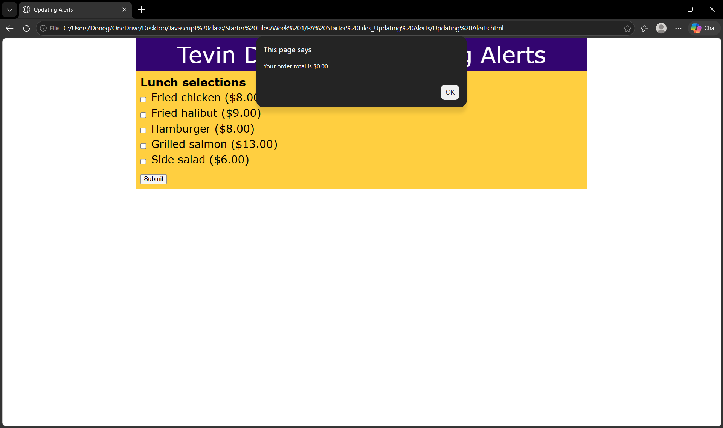
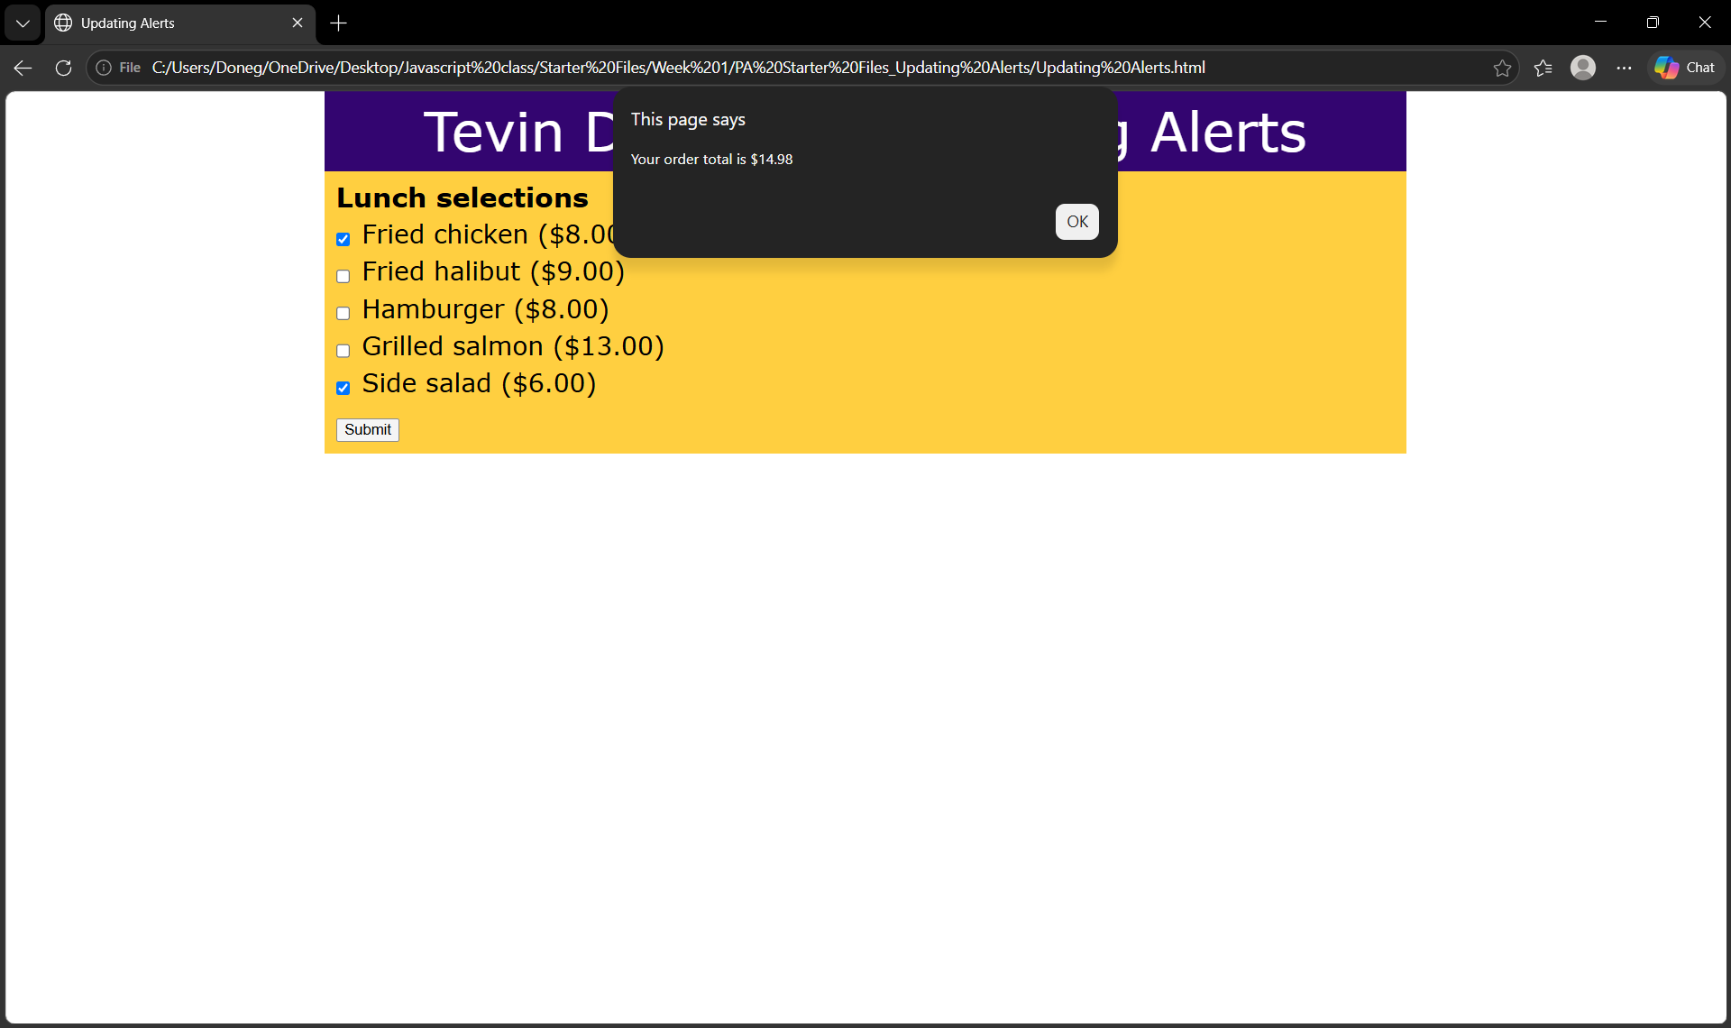
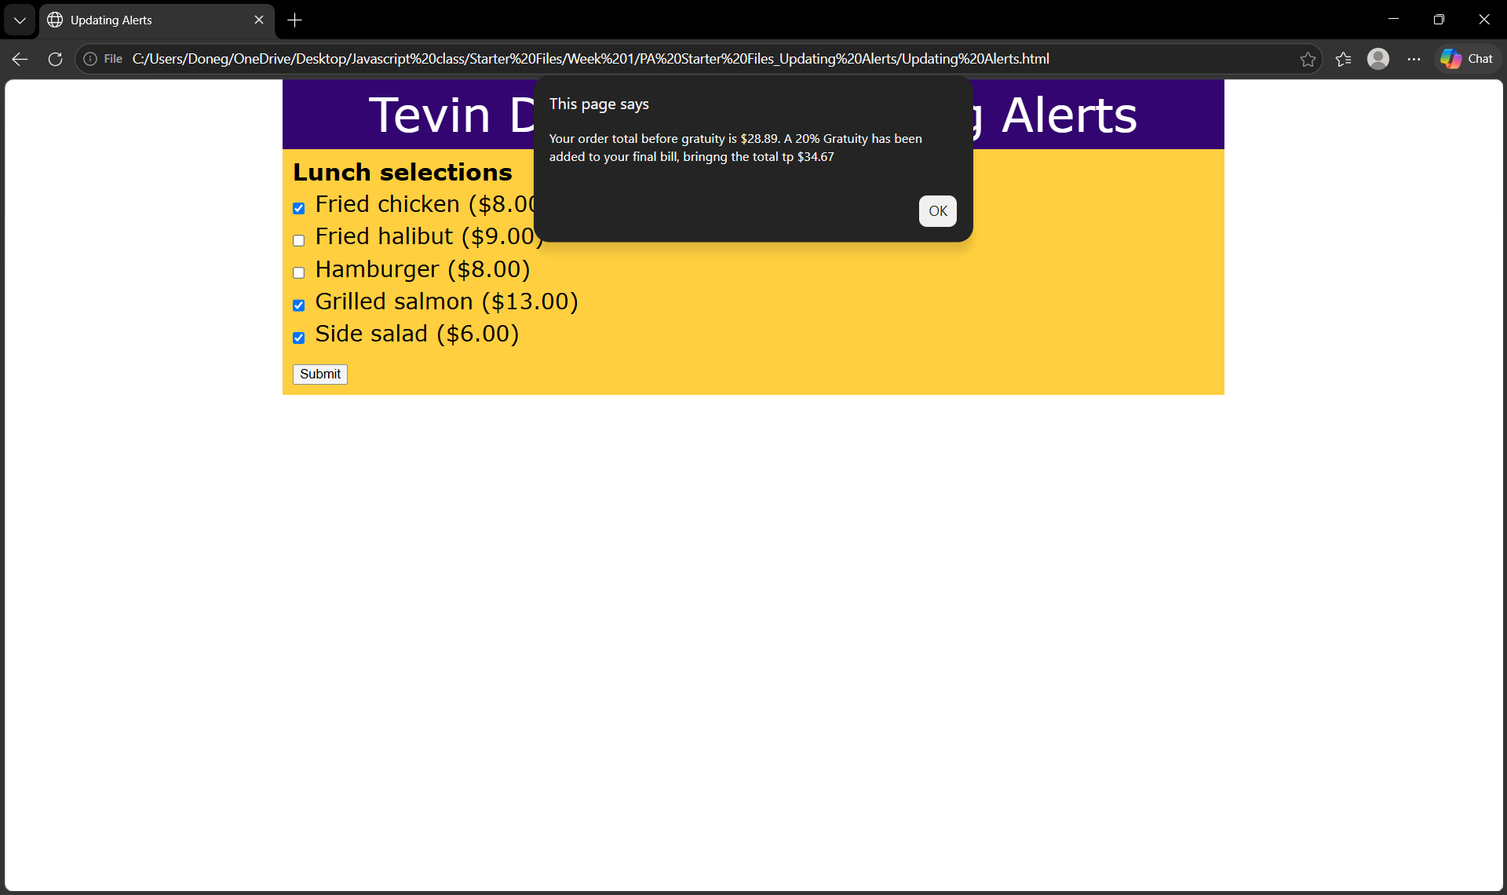

Code Screenshots
As you complete the procedure, add the required screenshots below.

